School-Parent Compact

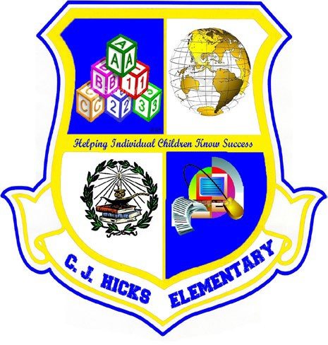
C.J. Hicks Elementary School
School Year: 2023 – 2024
Revision Date: March 23, 2023

Dear Parent/Guardian,

C.J. Hicks Elementary School students participating in the Title I, Part A program, and their families, agree that this School-Parent Compact outlines how the parents, the entire school staff, and the students will share the responsibility for improved student academic achievement as well as describes how the school and parents will build and develop a partnership that will help children achieve the State’s high standards.

JOINTLY DEVELOPED
Working together to support student success, the parents, students, and staff of C.J. Hicks Elementary School collaborated to develop a School-Parent Compact for achievement. Teachers encouraged reading at home with the family, and parents shared what resources and strategies they need to support their students’ education. Parents were encouraged to provide feedback about their needs through our annual Title I Parent and Family Engagement Survey to help teachers and staff understand student and parent needs. Additionally, parents were encouraged to attend annual Title I Revision Meetings in the spring to provide feedback on this School-Parent Compact as well as our school improvement goals.

To understand how working together can benefit your child, it is first important to understand the district’s and school’s goals for student academic achievement.

ROCKDALE COUNTY PUBLIC SCHOOLS’ GOAL:

Using FY23 results as a baseline measure, the district shall increase its CCRPI score by 3% of the gap between the baseline and 100.

C.J. HICKS ELEMENTARY SCHOOL GOALS:

To help your child meet the district and school goals, the school, you, and your child will work together to:
- By the end of the 2023-2024 school year, C.J. Hicks will increase the percentage of students scoring in the Proficient/Distinguished performance level on the ELA EOG assessment by 5% at each grade level as measured by performance on the Georgia Milestones Assessment System.
- By the end of the 2023-2024 school year, C.J. Hicks will increase the percentage of students scoring in the Proficient/Distinguished performance level on the Mathematics EOG assessment by 5% at each grade level as measured by performance on the Georgia Milestones Assessment System.
- By the end of the 2023-2024 school year, C.J. Hicks will increase the percentage of students scoring in the Proficient/Distinguished performance level on the Science EOG assessment by 5% as measured by performance on the Georgia Milestones Assessment System.

SCHOOL/TEACHER RESPONSIBILITIES:
To help your child meet the district and school goals, C.J. Hicks Elementary, parents, and students will work together to:

- Provide highly qualified personnel to work with students.
- Provide reading material for students to read at home and school.
- Provide students with homework that is meaningful and that reinforces learning from school.
- Provide opportunities for parents to volunteer in the school.
- Provide parent workshops to support learning at home.

PARENT RESPONSIBILITIES:
We, as parents, will:
- Send our children to school on time every day (Daily Instruction begins at 7:35 am).
- Encourage our children to read at home or have someone read to them.
- Talk with our children about what they are learning at school.
- Provide a quiet place for our children to do homework and study.
- Check our student’s homework assignments for completion.
- Review our students’ grades in the Parent Portal at least once per week.
- Review the documents in the red Wednesday communication folder and sign and return required documents.
- Read the Falcon Flyer and the CJH monthly parent newsletter.

STUDENT RESPONSIBILITIES:
•
•
•
•
•
•
•
Attend school on time every day (Daily Instruction begins at 7:35 am). Write down their assignments.
Complete and return assigned homework. Read daily at home.
Bring home notices and notes from the teacher and/or school.
Talk to their teachers and parents when they have questions about their learning. Honor the R.I.S.E. expectations for PBIS – Respect. Integrity. Safety. Empathy.
•
•
•
•
•
•
•
•
•
•
C.J. Hicks website
Infinite Campus Parent Portal
Homework Folders and Weekly Communication Folders Fall and Spring Parent-Teacher Conferences
Emails to Parents, PBIS Rewards Grade-Level Monthly Newsletters Phone Calls
School Messenger Phone System Remind App
Twitter Feeds
Please feel free to contact the school office, your child’s teacher, or the Parent Liaison, Mrs. Dawn Smith at 770-483-4410 if you have questions.
•

•

•

•

•

•
Open House – Parents have the opportunity to meet their child’s teacher and become acquainted with the school, faculty, and staff.
Parent-Teacher Conferences – Parents have the opportunity to meet with their student’s teacher and learn about their child’s progress.
Parent Pride Meetings – Parent workshops are presented with topics based on parents’ needs identified through parent surveys.
1st and 2nd Semester Curriculum Nights – 1st semester curriculum topics and assessments, as well as school rules and procedures are explained to parents. Parent Resource Center – Resources are available to support various topics related to parents’ needs and interests.
School Council – Parents are invited to serve on the School Council, which meets four times per year.
C.J. Hicks Elementary School students will:

COMMUNICATION ABOUT STUDENT LEARNING:
C.J. Hicks Elementary School is committed to frequent two-way communication with families about children’s learning. Some of the ways you can expect us to reach you are:

ACTIVITIES TO BUILD PARTNERSHIPS
C.J. Hicks Elementary School offers ongoing events and programs to build partnerships with families.

THIS PAGE IS INTENTIONALLY LEFT BLANK
Please sign the following page.

Please sign and date below to acknowledge that you have read, received, and agree to this School-Parent Compact. Once signed, please return the form to your child’s teacher. We look forward to our school-parent partnership!

School Representative Signature: | Date:
Parent/Guardian Signature: | Date:
Student Signature: | Date:

